**Feature of Eramba – Organization (Business Unit)**

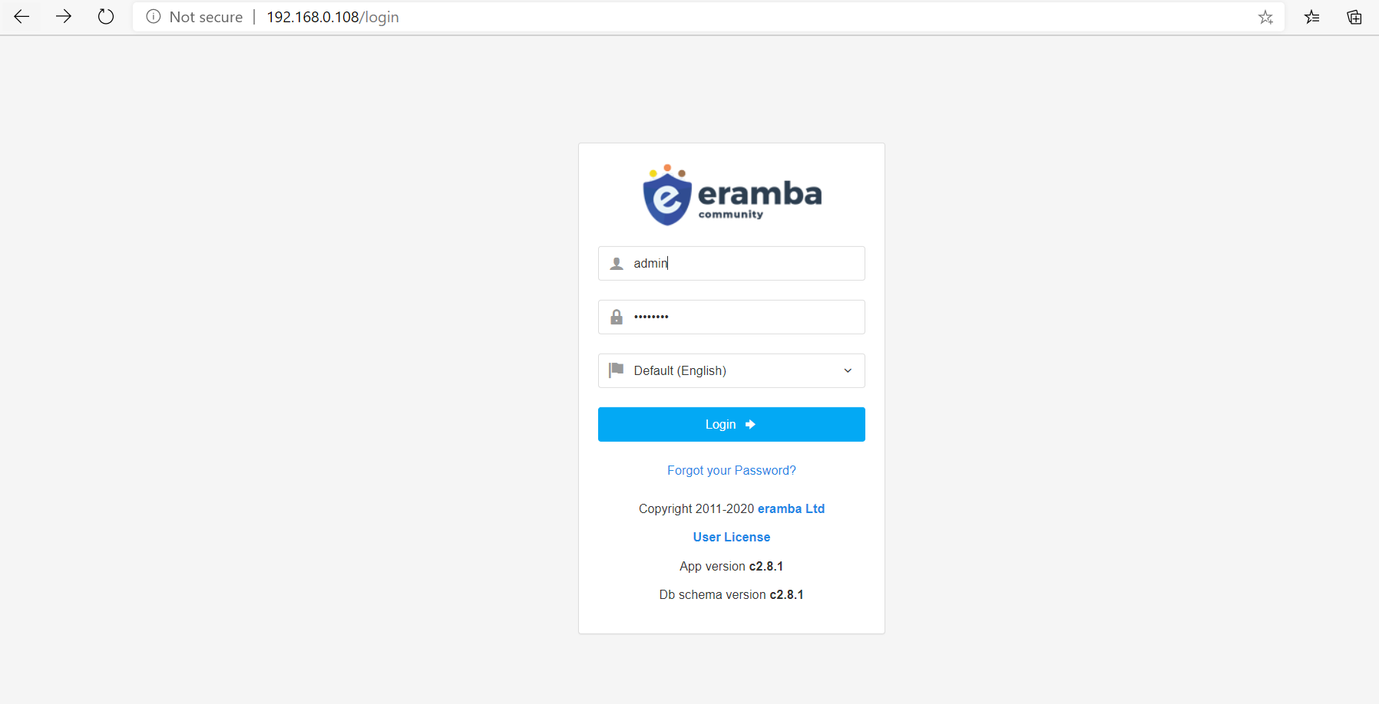

Select Organization option in left panel and select Business Unit

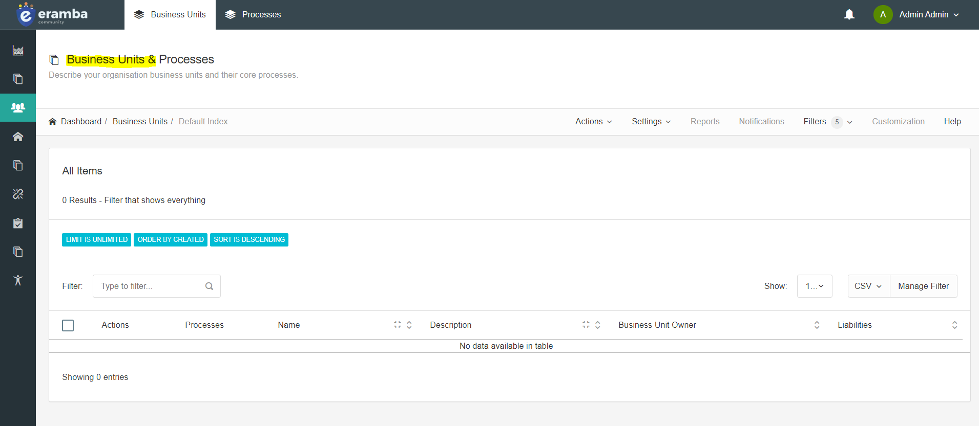

In Dashboard Menu click on Action and in drop down menu select on menu Add and add details about business and click on add button of business unit owner

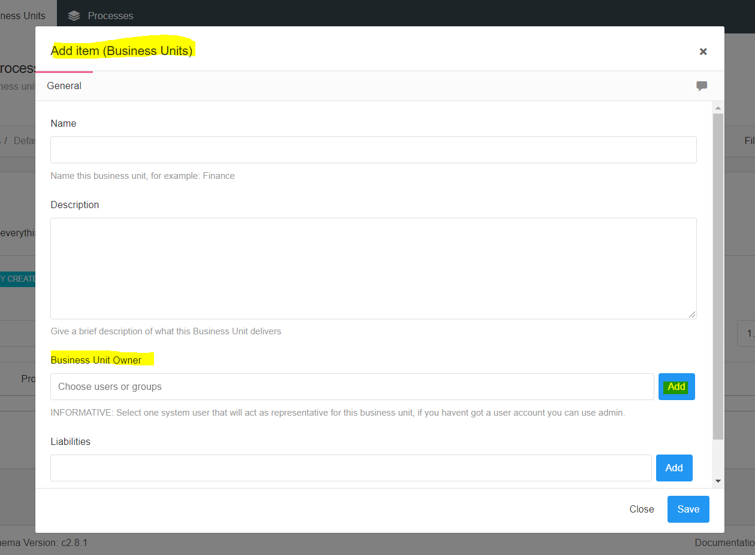

Pass is Sneha18@

Fill the details

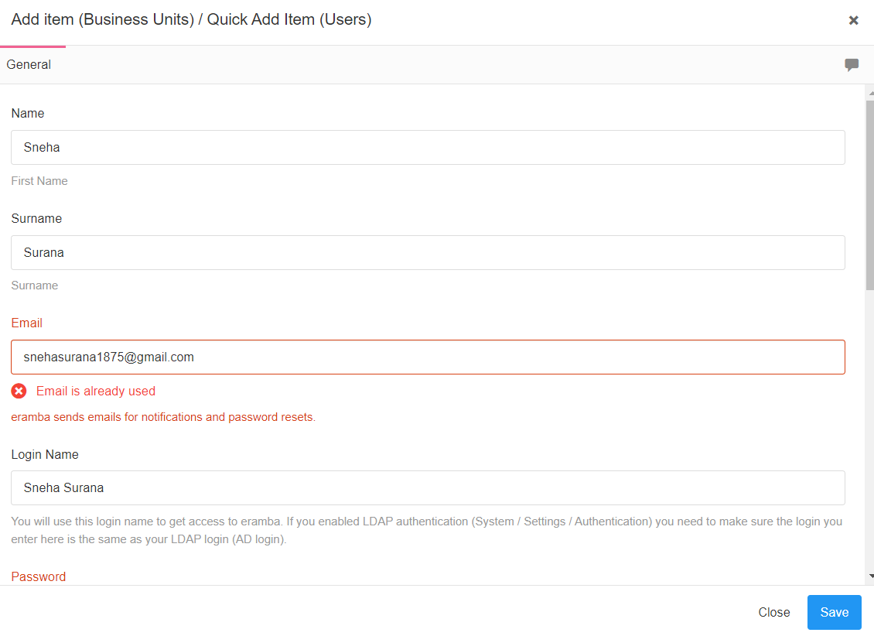

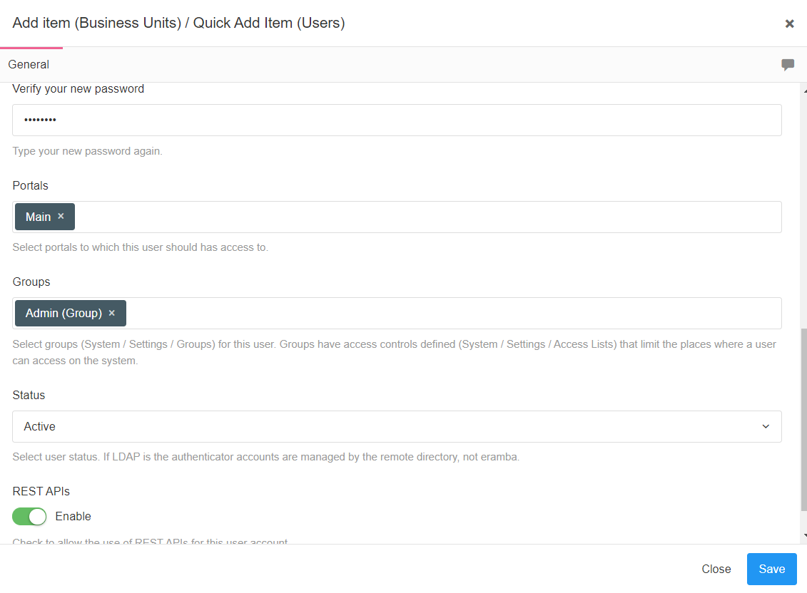

You will be redirected to add item and now add liability like I added ISO/ICE 27001:2013 and select as legal advisor as your name

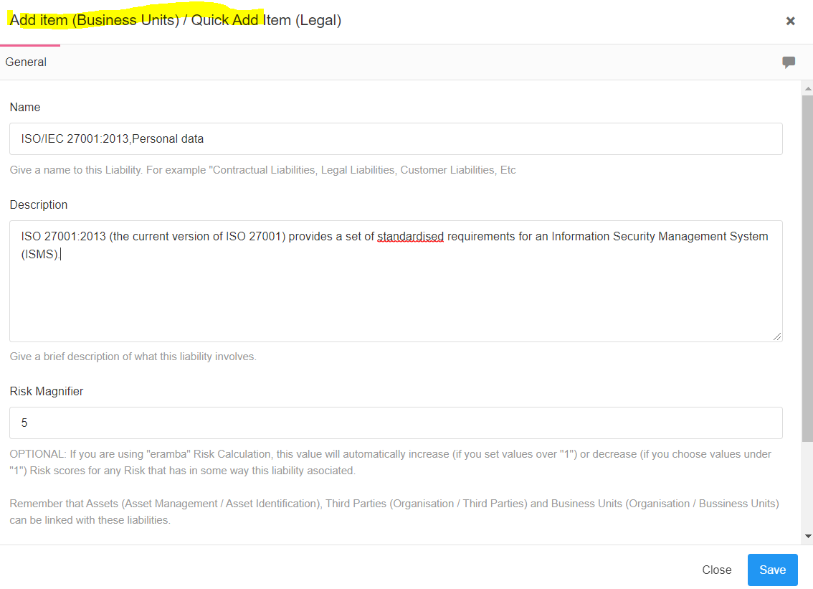

Now on is detail is Added similarly for others

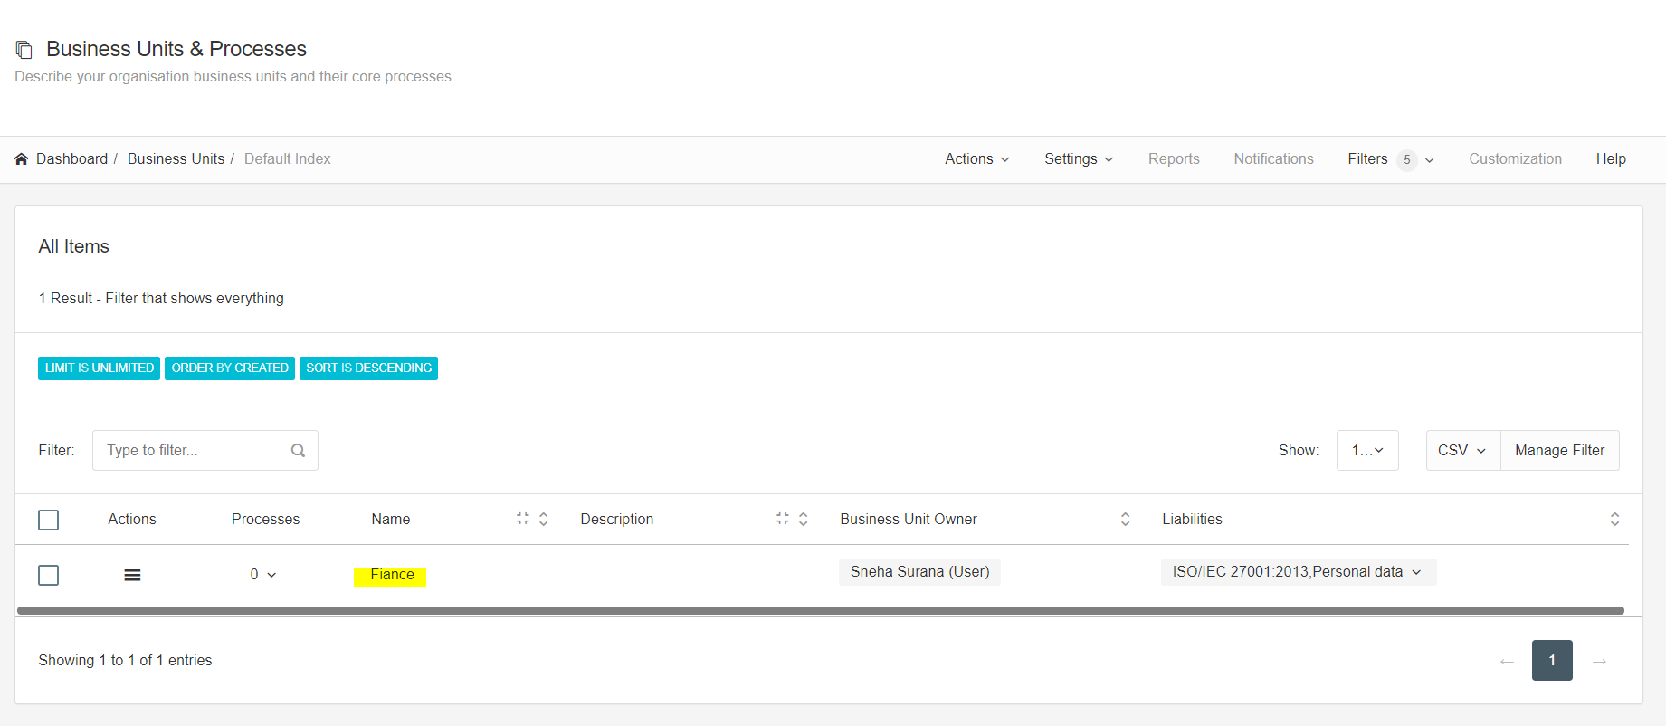

Add the details like that

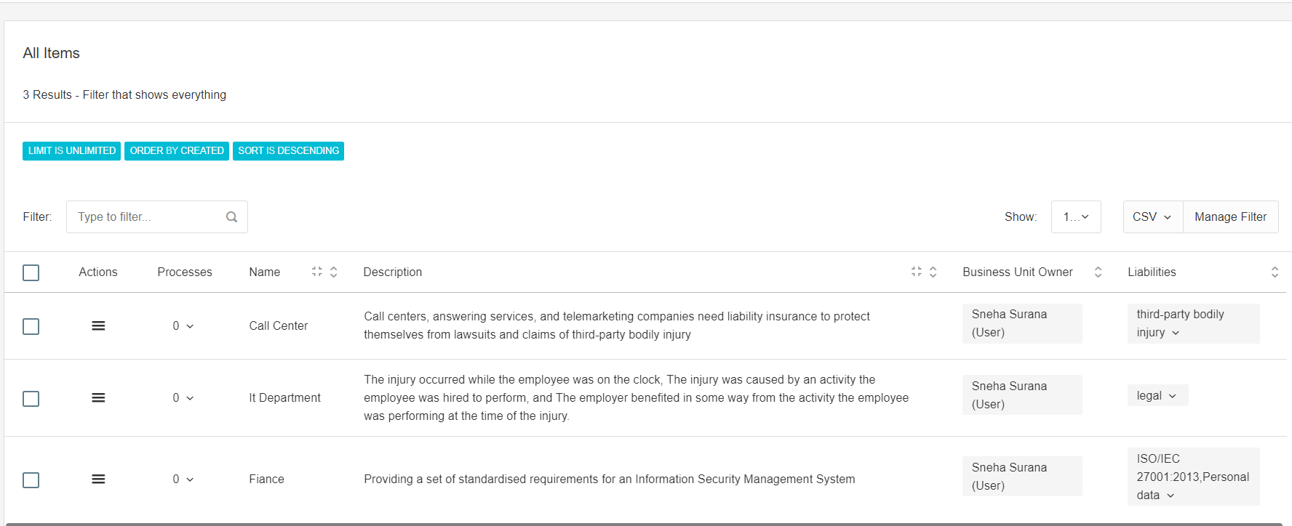

Now to add the records click and add new

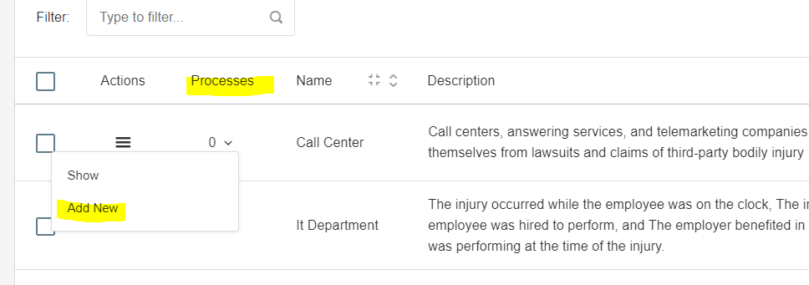

Now fill the details regarding of process and save it

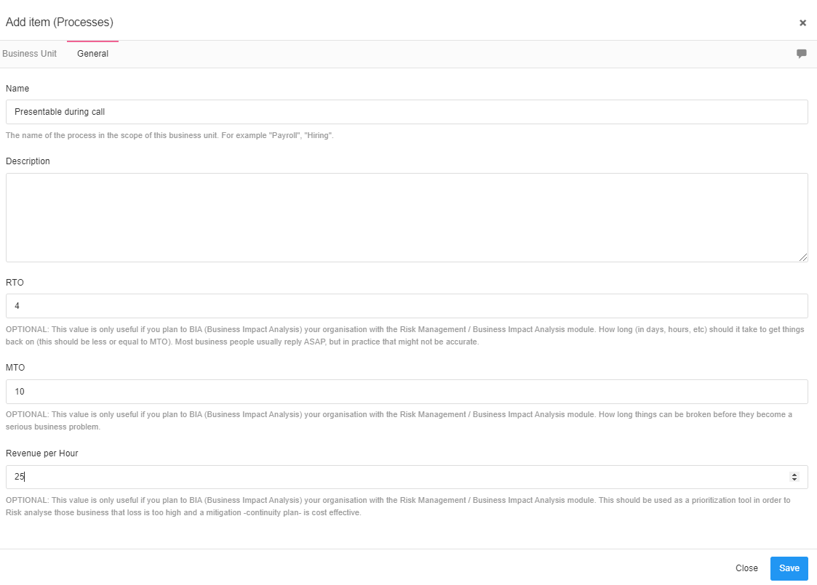

The record is added

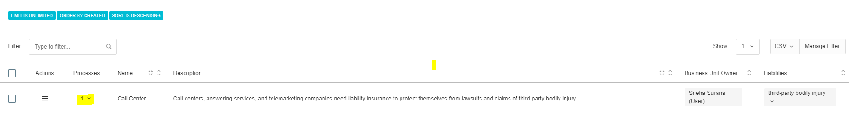

All the process have been created

